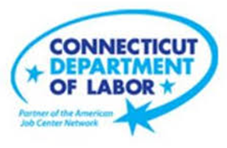

**NEW WEEKLY JOB POSTINGS FROM   
HELP WANTED ONLINE  
Office of Research**

**Week Ending August 13th, 2022: New Ads Down 21% Over the Week to 9,759.**WETHERSFIELD, August 19th, 2022 – During the week ending August 13th, there were 9,759 new postings, down 2,604 new ads or -21%% over the week. Employers with large over the week increases include Yale-New Haven Health System (-183 new ads), PricewaterhouseCoopers (-115 new ads), and Deloitte (-109 new ads). Occupations with the largest over the week decreases include Heavy & Tractor-Trailer Truck Drivers (-155new ads), Registered Nurses (-110 new ads), and Retail Salespersons (-86 new ads). This recent week of new ads is the lowest level in 6 weeks and follows the highest on record. Though down from recent weeks, the week ending August 13th, 2022 is up 44% from 52 weeks ago.  
  
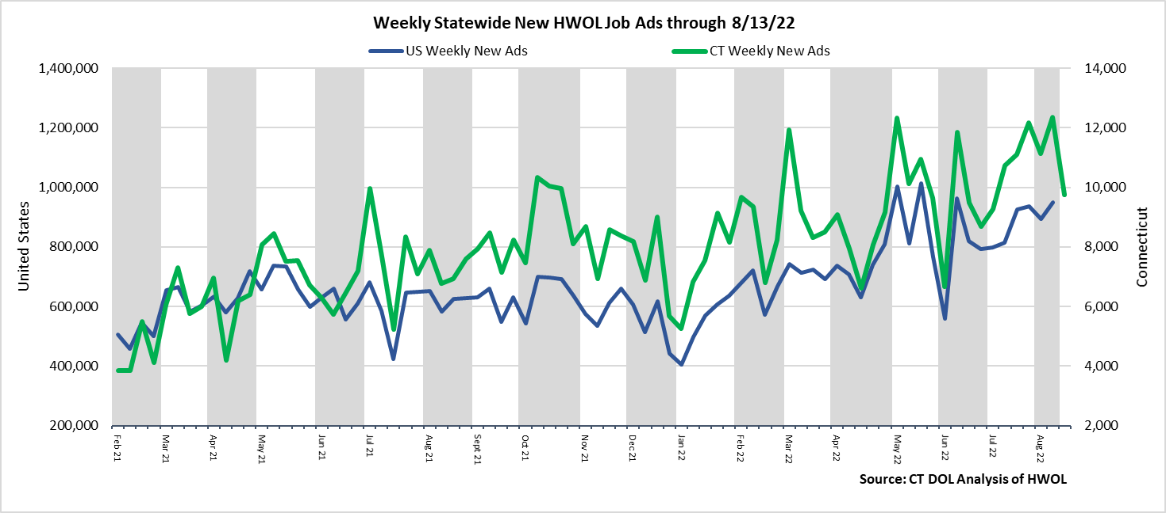  
**Industries** with the most new postings include Health Care & Social Assistance, Finance & Insurance, and Retail Trade.

**Occupations** with the most new postings include Registered Nurses, Retail Salespersons, and Customer Service Representatives.

**Employers** with the most new postings include Yale-New Haven Health System, Trinity Health, and Fidelity Brokerage Services.

**The three industries with the most new job postings were:**

* **Health Care & Social Assistance** (1,869 new postings, -29% over the week)
* **Finance & Insurance** (982 new postings, -13% over the week)
* **Retail Trade** (830 new postings, -26% over the week)

  
 During the week ending August 13th, 2022, the total ad decrease of -2,604 new ads or -21% is the net result of decreases in 14 of 21 industries. More than Half of the weekly decrease occurred in three industries: Health Care & Social Assistance (-764 new ads), Pro., Sci., & Tech. Services (-362 new ads), and Retail Trade (-294 new ads). The 7 increasing industries grew by a combined 138 new ads, with the largest occurring at Accommodation & Food Services (+54 new ads), Educational Services (-32 new ads), and Arts, Entertainment & Recreation (+25 new ads).  
Over 4 weeks, total new ads were down 1,347 new ads or -12%. 20 of 25 industries had 4 week declines, the largest decrease occurred in Professional, Scientific, & Technical Services (-366 new ads). The largest 4 week industry increase occurred in Educational Services (+107 new ads).  
  
 For more information on total job ads by industry for Connecticut and its labor market areas, see the monthly report available here: <https://www1.ctdol.state.ct.us/lmi/hwol.asp>

**New Job Postings by Occupation** 

**The occupations with the most new postings were:**

* Registered Nurses (406 new postings, -21% over the week)
* Retail Salespersons (256 new postings, -25% over the week)
* Customer Service Representatives (245 new postings, +60% over the week)

**Employers with the Most New Job Postings**

Employers with the most new job postings during the week were mostly in Healthcare & Social Assistance, Finance & Insurance, and Retail Trade. The 25 employers shown above account for 16 percent of all new ads. 14 of 25 employers in the top 25 had over the week increases. The largest increases in the top 25 include Trinity Health (+64 new ads), Aya Healthcare (+46 new ads), and Lincoln Financial Group (+37 new ads). The 14 increasing employers in the top 25 grew by a combined 395 new ads, one was unchanged, and the 10 decreasing ads fell by a combined 588 new ads. The largest decreases over the week include Yale-New Haven Health System (-183 new ads) and PricewaterhouseCoopers (-115 new ads). Over four weeks, 20 employers in the top 25 had increases, one was unchanged, and 4 had decreases. The largest four-week increase occurred at Fidelity Brokerage Services (+101 new ads) and the largest decrease occurred at CVS Health (-58 new ads).   
  
**What is HWOL?**The **Conference Board Help Wanted Online**® Data Series (HWOL) measures the number of new, first-time Online job postings and jobs reposted from the previous month for over 16,000 Internet job boards, corporate boards and smaller job sites that serve niche markets and smaller geographic areas. To view more HWOL data, go to: <https://www1.ctdol.state.ct.us/lmi/hwol.asp>